# Exercises: String Processing

This document defines the exercises for ["Java Advanced" course @ Software University](https://softuni.bg/courses/java-advanced). Please submit your solutions (source code) of all below described problems in [Judge](https://judge.softuni.bg/Contests/1036/String-Processing-Exercises).

## Count Substring Occurrences

Write a program to find **how many times** a given **string** **appears in a given text** as substring. The text is given at the first input line. The search string is given at the second input line. The output should be an integer number. Ignore the **character casing**. **Overlapping** between occurrences is **allowed**.

### Examples

|  |  |
| --- | --- |
| **Input** | **Output** |
| **Wel**come to the Software University (SoftUni)! **Wel**come to programming. Programming is **wel**lness for developers, said Max**wel**l.  wel | 4 |
| **aaaaaa**  aa | 5 |
| **ababa** c**aba**  aba | 3 |
| Welcome to SoftUni  Java | 0 |

### Hints

* For ignoring the character casing, you will need two strings, the one uppercase, and the other lowercase.

## Sum Big Numbers

You are given two lines - each can be a really big number (0 to 1050). You must display the sum of these numbers.

Note: do not use the **BigInteger** or **BigDecimal** classes for solving this problem.

### Examples

|  |  |  |  |
| --- | --- | --- | --- |
| **Input** | **Output** | **Input** | **Output** |
| 23  23 | 46 | 9999  1 | 10000 |
| **Input** | | | | **Output** |
| 923847238931983192462832102  934572893617836459843471846187346 | | | | 934573817465075391826664309019448 |

## Text Filter

Write a program that takes a **string of banned words** anda **text**. All words included in the ban list should be replaced with "**\***", equal to the word's length. The entries in the ban list will be separated with a **comma** and a **space** "**,** ".

The ban list should be entered on the first input line and the text on the second input line.

### Examples

|  |  |
| --- | --- |
| **Input** | **Output** |
| Linux, Windows  It is not **Linux**, it is GNU/**Linux**. **Linux** is merely the kernel, while GNU adds the functionality. Therefore we owe it to them by calling the OS GNU/**Linux**! Sincerely, a **Windows** client | It is not *****, it is GNU/*****. ***** is merely the kernel, while GNU adds the functionality. Therefore we owe it to them by calling the OS GNU/*****! Sincerely, a ******* client |

## Unicode Characters

Write a program that converts a string to a sequence of Unicode character literals.

### Examples

|  |  |
| --- | --- |
| **Input** | **Output** |
| Hi! | \u0048\u0069\u0021 |
| What?!? | \u0057\u0068\u0061\u0074\u003f\u0021\u003f |
| SoftUni | \u0053\u006f\u0066\u0074\u0055\u006e\u0069 |

### Hints

* Look here for some of the [StringBuilder methods](https://docs.oracle.com/javase/7/docs/api/java/lang/StringBuilder.html). The Problem is very easy if you the find right method.

## Palindromes

Write a program that extracts from a given text all palindromes, e.g. **ABBA, lamal, exe** and prints them separated by a comma and a space. Use **spaces**, **commas**, **dots**, **question** **marks** and **exclamation** **marks** as word delimiters. Print all **unique** palindromes, **sorted** **lexicographically**.

### Examples

|  |  |
| --- | --- |
| **Input** | **Output** |
| Hi,exe? ABBA! Hog fully a string. Bob | [ABBA, a, exe] |
| aibohphobia is fear of palindromes ahahaha | [ahahaha, aibohphobia] |
| aSantAAtnaSa is a rare sight | [a, aSantAAtnaSa] |

### Hints

* **TreeSet** is a data structure, which sorts words lexicographically immediately after adding a new one.



## Magic Exchangeable Words

Write a **method** that takes as input two strings, and returns true if they are exchangeable. **Exchangeable** are words, where the characters in the first string can be replaced to get the second string.

Example: "**egg"** and "**add"** are exchangeable, but "**aabccbb"** and "**nnoppzz"** are not. (First '**b'** corresponds to '**o'**, but then it also corresponds to '**z'**).

The two words may not have the same length, if such is the case they are exchangeable only if the longer one doesn't have more types of characters then the shorter one ("**Clint"** and **"Eastwaat"** are exchangeable because '**a'** and **'t'** are already mapped as '**l'** and **'n'**, but "**Clint"** and **"Eastwood**" aren't exchangeable because '**o'** and '**d'** are not contained in "**Clint"**).

### Examples

|  |  |
| --- | --- |
| **Input** | **Output** |
| gosho hapka | true |
| aabbaa ddeedd | true |
| foo bar | false |
| Clint Eastwood | false |

## * Letters Change Numbers

Nakov likes Math. But he also likes the English alphabet a lot. He invented a game with numbers and letters from the **English** alphabet. The game was simple. You get a string consisting of a **number between two letters**. Depending on whether the letter was in front of the number or after it you would perform different mathematical operations on the number to achieve the result.

**First** you start with the letter **before** the number. If it's **Uppercase** you **divide** the number by the letter's **position** in the alphabet. If it's **lowercase** you **multiply** the number with the letter's position. **Then** you move to the **letter after** the number. If it's **Uppercase** you **subtract** its position from the resulted number. If it's **lowercase** you **add** its position to the resulted number. But the game became too easy for Nakov really quick. He decided to complicate it a bit by doing the same but with **multiple** strings keeping track of only the **total sum** of all results. Once he started to solve this with more strings and bigger numbers it became quite hard to do it only in his mind. So he kindly asks you to write a program that **calculates the sum of all numbers after the operations on each number have been done**.

**For example**, you are given the sequence "**A12b s17G**". We have two strings – **"A12b"** and **"s17G"**. We do the operations on each and sum them. We start with the letter before the number on the first string. **A is Uppercase** and its position in the alphabet is **1**. So we divide the number 12 with the position 1 (**12/1 = 12)**. Then we move to the letter after the number. **b is lowercase** and its position is 2. So we add 2 to the resulted number (**12+2=14)**. Similarly for the second string **s is lowercase** and its position is 19 so we multiply it with the number (**17*19 = 323)**. Then we have Uppercase G with position 7, so we subtract it from the resulted number (**323 – 7 = 316)**. Finally we sum the 2 results and we get **14 + 316=330**;

### Input

The input comes from the console as a **single line, holding the sequence of strings**. Strings are separated by **one or more white spaces**.

The input data will always be valid and in the format described. There is no need to check it explicitly.

### Output

Print at the console a single number: the **total sum of all processed numbers** rounded up to **two digits** after the decimal separator.

### Constraints

* The **count** of the strings will be in the range **[1 … 10].**
* The numbers between the letters will be integers in range **[1 … 2 147 483 647].**
* Time limit: 0.3 sec. Memory limit: 16 MB.

### Examples

|  |  |  |
| --- | --- | --- |
| **Input** | **Output** | **Comment** |
| A12b s17G | 330.00 | 12/1=12, 12+2=14, 17*19=323, 323–7=316, **14+316=330** |
| P34562Z q2576f H456z | 46015.13 |  |
| a1A | 0.00 |  |

## ** Melrah Shake

You are given a **string** of random characters, and a **pattern** of random characters. You need to “shake off” (**remove**) all of the **border** occurrences of that pattern, in other words, the **very** **first** **match** and the **very last match** of the pattern you find in the string.

When you successfully shake off a match, you **remove** from the pattern the character which corresponds to the **index** equal to **the pattern’s length / 2**. Then you continue to shake off the border occurrences of the new pattern until the pattern becomes **empty** or until there is **less** than the - needed for shake, matches in the remaining string.

In case you have found at least **two** matches, and you have successfully shaken them off, you print “Shaked it.” on the console. Otherwise you print “No shake.”, the remains of the main string, and you end the program. See the examples for more info.

### Input

* The input will consist only of two lines.
* On the first line you will get a string of random characters.
* On the second line you will receive the pattern and that ends the input sequence.

### Output

* You must print “Shaked it.” for every time you successfully do the melrah shake.
* If the melrah shake fails, you print “No shake.”, and on the next line you print what has remained of the main string.

### Constraints

* The two strings may contain **ANY** ASCII character.
* Allowed time/memory: 250ms/16MB.

### Examples

|  |  |
| --- | --- |
| **Input** | **Output** |
| astalavista baby  sta | Shaked it.  No shake.  alavi baby |

|  |  |
| --- | --- |
| **Input** | **Output** |
| ##mtm!!mm.mm*mtm.#  mtm | Shaked it.  Shaked it.  No shake.  ##!!.*.# |

## Match Full Name

Write a regular expression to match a **valid full name**. If you catch a valid match, print it as an output.

A **valid full** **name**:

* **Consists** of two words
* Each **word starts** with a capital letter
* Each **word contains** only lowercase letters afterwards
* Each word should be at least **two letters long**
* The two words should be **separated by a single space**

Read lines until you get the "**end**" command.

### Examples

|  |  |
| --- | --- |
| **Input** | **Output** |
| ivan ivanov  Ivan ivanov  ivan Ivanov  IVan Ivanov  Ivan IvAnov  Ivan Ivanov  Ivan Ivanov  end | Ivan Ivanov |

### Hints

* Open <https://regex101.com/> or a similar regex testing site
* Paste the provided test string and start writing your regex:

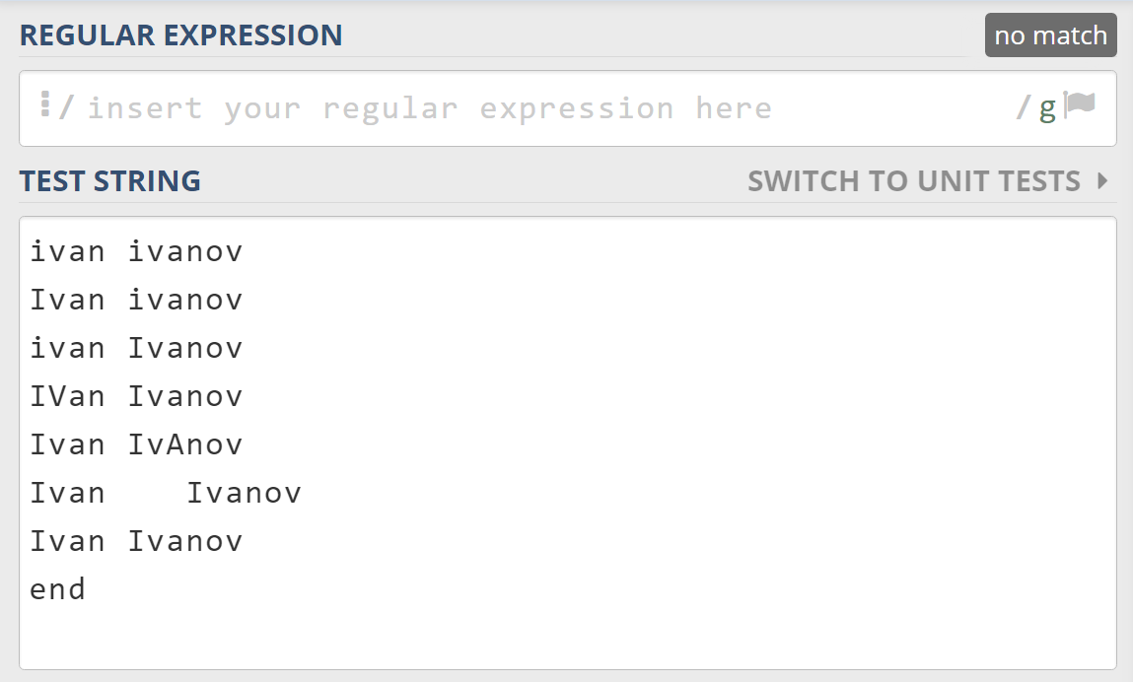

* Start with first name
* Add "m" to modifiers which specifies that you are testing a multi-line input



* Use character classes to match a single capital letter:



* Use character classes and a quantifier to match a series of lowercase letters:



* Add a single space and repeat the same regex for the second name:



* Surround the regex with anchors ^ and $ to specify the start and the end of the regex

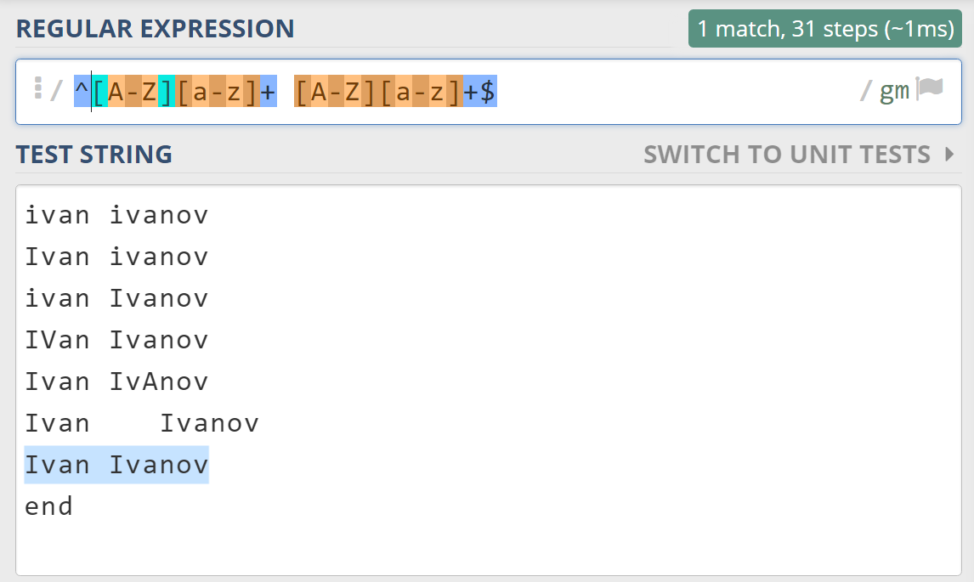

* Create your java application using the regex that you've created:

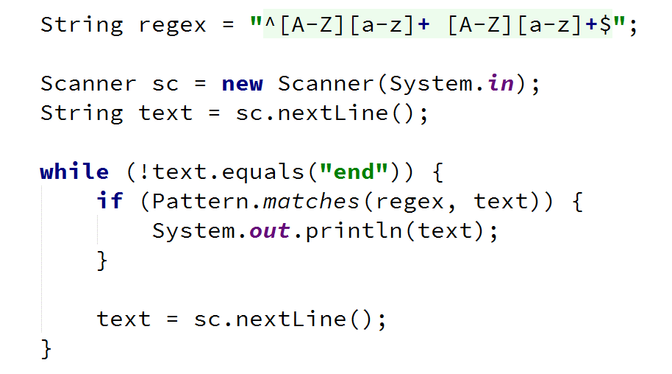

## Match Phone Number

Write a regular expression to match a **valid phone number**.

A **valid number**:

* **Starts** with "+359"
* **Followed** **by** the area code "2"
* **Followed by** number itself, consisting of 7 digits (separated in two group of 3 and 4 digits respectively)
* Every part of the number should be **separated by either a space** (' ') **or a hyphen** ('-'), but not both in a same valid number

Read lines until you get the **"end"** command.

### Examples

|  |  |
| --- | --- |
| **Input** | **Output** |
| +359 2 222 2222  +359-2-222-2222  359-2-222-2222  +359/2/222/2222  +359-2 222 2222  +359 2-222-2222  +359-2-222-222  +359-2-222-22222  end | +359 2 222 2222  +359-2-222-2222 |

### Hints

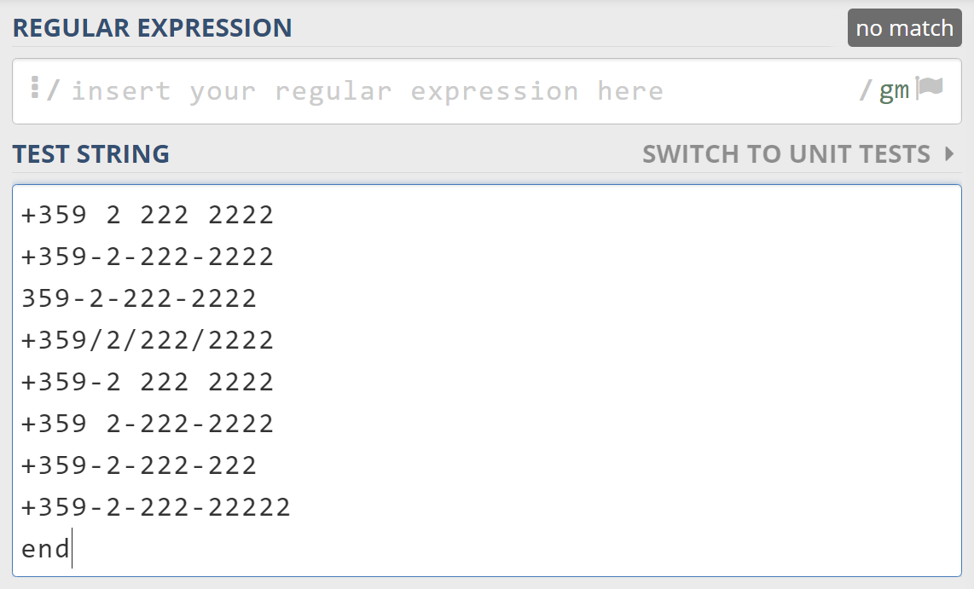

* Add "m" to modifiers which specifies that you are testing a multi-line input



* Start your regex with the country code, you need to escape the + sign



* To match one of the two possible separators, use grouping and a character class



* Add the city code which is a literal



* Match the previous separator by using a backreference



* Add the next three digits



* Do the same for the last separator and the last four digits
* Surround the regular expression with anchors to make sure it wouldn't match longer numbers



## Replace <a> Tag

You are given an HTML document given as a string on multiple lines. Write a programthat replaces **all the tags** <a href=…>…</a> with corresponding **tags** [URL href=…]…[/URL].

Read lines until you get the **"END"** command.

**Note:** a tag can start and end on different lines, but actual keywords like "href=" or the closing tag "</a>" will never be split. For example, you will never get:

<a hr

ef="http://softuni.bg">SoftUni</

a>

### Examples

|  |  |
| --- | --- |
| **Input** | **Output** |
| <ul> <li> <a href="http://softuni.bg">SoftUni</a>  </li> </ul>  END | <ul> <li>  **[URL** href=http://softuni.bg**]**SoftUni**[/URL]**  </li>  </ul> |
| <a href="/">  Link</a>  END | **[URL** href="/"**]**  Link**[/URL]** |

### Hints

* Use a **StringBuilder** to read the whole input into a single string. Make sure to save the new lines.
* Create a pattern that can match a valid tag on multiple lines.
* **Replace** all matches.

## Extract Emails

Write a program to **extract all email addresses from a given text**. The text comes from a single input line. Print the emails on the console, each on a separate line. Emails are considered to be in format **<user>@<host>**, where:

* **<user>** is a sequence of letters and digits, where '**.**', '**-**' and '**_**' can appear between them.
  + **Valid users**: "stephan", "mike03", "s.johnson", "st_steward", "softuni-bulgaria", "12345".
  + I**nvalid users**: ''--123", ".....", "nakov_-", "_steve", ".info".
* **<host>** is a sequence of at least two words, separated by dots '**.**'. Each word is sequence of letters and can have hyphens '**-**' between the letters.
  + V**alid hosts**: "softuni.bg", "software-university.com", "intoprogramming.info", "mail.softuni.org".
  + I**nvalid hosts**: "helloworld", ".unknown.soft.", "invalid-host-", "invalid-".

**Emails should start** with either a space (' ') or with line start (regex: ^) and **end with** dot ('.'), comma (','), space (' ') or line end (regex: $).

* **Valid emails**: info@softuni-bulgaria.org, kiki@hotmail.co.uk, no-reply@github.com, s.peterson@mail.uu.net, info-bg@software-university.software.academy.
* **Invalid emails**: --123@gmail.com, …@mail.bg, [.info@info.info](mailto:.info@info.info), [_steve@yahoo.cn](mailto:_steve@yahoo.cn), mike@helloworld, [mike@.unknown.soft](mailto:mike@.unknown.soft)., [s.johnson@invalid-](mailto:s.johnson@invalid-).

Read lines until you get the **"end"** command.

### Examples

|  |  |
| --- | --- |
| **Input** | **Output** |
| info@softuni-bulgaria.org, --123@gmail.com, kiki@hotmail.co.uk, no-reply@github.com, …@mail.bg, s.peterson@mail.uu.net, .info@info.info, info-bg@software-university.software.academy, _steve@yahoo.cn, mike@helloworld, mike@.unknown.soft, s.johnson@invalid-  end | info@softuni-bulgaria.org  kiki@hotmail.co.uk  no-reply@github.com  s.peterson@mail.uu.net  info-bg@software-university.software.academy |
| Please contact us at: support@github.com.  end | support@github.com |
| Just send email to s.miller@mit.edu and j.hopking@york.ac.uk for more information.  end | s.miller@mit.edu  j.hopking@york.ac.uk |
| Many users @ SoftUni confuse email addresses. We @ Softuni.BG provide high-quality training @ home or @ class. –- steve.parker@softuni.de.  end | steve.parker@softuni.de |
| --123@gmail.com, …@mail.bg, .info@info.info, _steve@yahoo.cn, mike@helloworld, mike@.unknown.soft., s.johnson@invalid-.  end | *(no output)* |

### Hints

* Learn about [positive and negative lookahead and lookbehind](http://www.regular-expressions.info/lookaround.html).
* Use anchors, character classes, quantifiers and literals

## Sentence Extractor

Write a program that reads a **keyword** and some **text** from the console and prints **all sentences from the text, containing that word**.

A sentence is any sequence of words that:

* ends with a dot ('.'), an exclamation mark ('!') or a question mark ('?').

### Examples

|  |  |
| --- | --- |
| **Input** | **Output** |
| is  This **is** my cat! And this **is** my dog. We happily live in Paris – the most beautiful city in the world! Isn’t it great? Well it is :) | This is my cat!  And this is my dog. |
| is  No keyword in this sentence. | *(no output)* |

## *Sum of All Values

You are given a **keys string** and a **text string**. Write a program that finds the **start key** and the **end key** from the **keys string** and then **applies** **them** to the **text string**.

The **start key** will **always** stay at the **beginning** of the **keys string**. It can contain **only letters and underscore** and **ends** just before the **first found digit**.

The **end key** will **always** stay at the **end** of the **keys string**. It can contain **only letters and underscore** and **starts** just after the **last found digit**.

Print at the console the **sum of all values (only integer and floating-point numbers with dot as a separator are considered valid)** in the **text string,** between a **start** **key** and an **end key**. If the value is 0 then print “The total value is: *nothing*”. If no start key or no end key is found, then print “A key is missing”.

### Input

The input will be read from the console. The first line will hold the keys string and the second line will hold the text to search.

### Output

The output should hold the **result text**, printed in an HTML paragraph.

If the resulting sum is a floating-point number, format it to the second digit after the decimal point and don’t print any numbers after the decimal point, if the sum is an integer.

### Constraints

* The **keys string and text string** will hold only **ASCII** characters (no Unicode).
* Allowed working time: 0.1 seconds. Allowed memory: 16 MB.

### Examples

|  |  |
| --- | --- |
| **Input** | |
| keysString | **startKEY**12adghfgh243212gadghfgs43**endKEY** |
| textString | asdjykulgfjddfsffd**startKEY***12***endKEY**qwfrhtyu67543rewghy3tefdgd **startKEY***123.45***endKEY**wret34yre**startKEY***2.6***endKEY**213434ytuhrgerweasfd **startKEYendKEYstartKEY***asfdge***endKEY** |
| **Output** | |
| <p>The total value is: <em>138.05</em></p> | |

|  |  |
| --- | --- |
| **Input** | |
| keysString | **startKEY**12**a** |
| textString | asdjykulgfjddfsffd**startKEY***12endKEYqwfrhtyu67543rewghy3tefdgdst***a**rtKEY123.45endKEYwret34yre**startKEY***2.6endKEY213434ytuhrgerwe***a**sfd **startKEY***endKEYst***a**rtKEYasfdgeendKEY |
| **Output** | |
| <p>The total value is: <em>nothing</em></p> | |

|  |  |
| --- | --- |
| **Input** | |
| keysString | **startKEY**12 |
| textString | asdjykulgfjddfsffdstartKEY12endKEYqwfrhtyu67543rewghy3tefdgd |
| **Output** | |
| <p>A key is missing</p> | |

## *Valid Usernames

You are part of the back-end development team of the next Facebook. You are given **a line of usernames**, between one of the following symbols**: space, “/”, “\”, “(“, “)”.** First you have to export all **valid** usernames. A valid username **starts with a letter** and can contain **only letters, digits and “_”**. It cannot be **less than 3 or more than 25 symbols** long. Your task is to **sum** the length of **every** **2 consecutive** **valid** usernames and print on the console the 2 valid usernames with **biggest** **sum** of their **lengths,** each on a separate line.

### Input

The input comes from the console. One line will hold all the data. It will hold **usernames,** divided by the symbols: **space, “/”, “\”, “(“, “)”.**

The input data will always be valid and in the format described. There is no need to check it explicitly.

### Output

Print at the console the 2 **consecutive** **valid usernames** with the **biggest** **sum** of their lengths each on a separate line. If there are **2 or more couples** of usernames with the same sum of their lengths, print he **left most**.

### Constraints

* The input line will hold characters in the range [0 … 9999].
* The usernames should **start with a letter** and can contain **only letters, digits and “_”**.
* The username cannot be **less than 3 or** **more than 25 symbols** long.
* Time limit: 0.5 sec. Memory limit: 16 MB.

### Examples

|  |  |
| --- | --- |
| **Input** | **Output** |
| ds3bhj y1ter/wfsdg 1nh_jgf ds2c_vbg\4htref | wfsdg  ds2c_vbg |

|  |  |
| --- | --- |
| **Input** | **Output** |
| min23/ace hahah21 ( sasa ) att3454/a/a2/abc | hahah21  sasa |

|  |  |
| --- | --- |
| **Input** | **Output** |
| chico/ gosho \ sapunerka (3sas) mazut lelQ_Van4e | mazut  lelQ_Van4e |

## **Extract Hyperlinks

Write a program to **extract all hyperlinks** (<href=…>) from a given text. The text comes from the console on a variable number of lines and ends with the command "END". Print at the console the href values in the text.

The input text is **standard HTML code**. It may hold many tags and can be formatted in many different forms (with or without whitespace). The <a> elements may have many attributes, not only href. You should extract only the values of the href attributes of all <a> elements.

### Input

The input data comes from the console. It ends when the **"END"** command is received.

### Output

Print at the console the href values in the text, each at a separate line, in the order they come from the input.

### Constraints

* The input will be **well formed HTML fragment** (all tags and attributes will be correctly closed).
* Attribute values will never hold tags and hyperlinks, e.g. "<img alt='<a href="hello">' />" is invalid.
* Commented links are also extracted.
* The number of input lines will be in the range **[1 ... 100]**.
* Allowed working time: **0.1 seconds**. Allowed memory: **16 MB**.

### Examples

|  |  |
| --- | --- |
| **Input** | **Output** |
| <a href="http://softuni.bg" class="new"></a>  END | http://softuni.bg |
| <p>This text has no links</p>  END |  |
| <!DOCTYPE html>  <html>  <head>  <title>Hyperlinks</title>  <link href="theme.css" rel="stylesheet" />  </head>  <body>  <ul><li><a **href="/"** id="home">Home</a></li><li><a  class="selected" **href=/courses**>Courses</a>  </li><li><a **href =**  **'/forum'** >Forum</a></li><li><a class="href"  onclick="go()" **href= "#"**>Forum</a></li>  <li><a id="js" **href =**  **"javascript:alert('hi yo')"** class="new">click</a></li>  <li><a id='nakov' **href =**  **http://www.nakov.com** class='new'>nak</a></li></ul>  <a **href="#empty"**></a>  <a id="href">href='fake'<img src='http://abv.bg/i.gif'  alt='abv'/></a><a **href="#"**>&lt;a href='hello'&gt;</a>  <!-- This code is commented:  <a href="#commented">commentex hyperlink</a> -->  </body>  END | /  /courses  /forum  #  javascript:alert('hi yo')  http://www.nakov.com  #empty  #  #commented |